Assignment 4

**Part 1:**

1. A) 𝐴⟺𝐵⊨¬𝐴∨𝐵

B) (𝐴∧𝐵)⇒𝐶⊨(𝐴⇒𝐶)∨(𝐵⇒𝐶)

1. A) 𝐴⟺(𝐵∨𝐸)

B) 𝐶∧𝐹⇒¬𝐵

C) ¬((¬𝐴 ⇒ ¬𝐵) ∧ ¬𝐶)

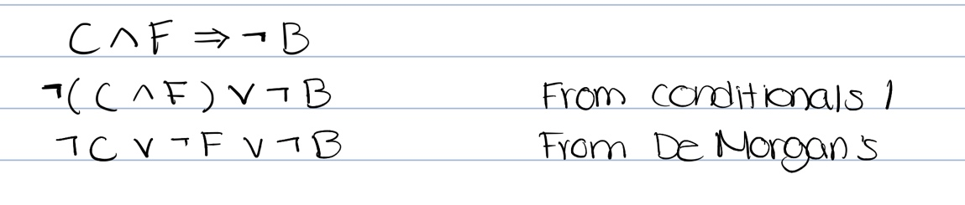

D) (𝐴⇒𝐵)⇒(¬𝐶∧𝐵)

1. Natural English Translation
   1. Everyone is male or female
   2. All people who speak the same language understand eachother
   3. Joan is a mother of one child
   4. Joan and Kevin are parents of the same child
   5. There exists a planet in which all humans live on
   6. All students take a course
   7. No two individuals do not have the same SSN
   8. All people’s SSN’s contain 9 digits
2. General Unifier
   1. {x/A, y/B, z/B}
   2. Cannot unify A with B
   3. {y/John, x/John}
   4. Cannot unify y with father()

**Part 2:**

1. Was George the parent of Oliver?
   1. Graphical user interface, text

      Description automatically generated
2. Who was Oliver's parent?
   1. Text

      Description automatically generated
3. Who were the children of Oliver?
   1. Text

      Description automatically generated
4. Who were the brothers of Anne?
   1. Text

      Description automatically generated with medium confidence
5. Who were the cousins of Rose?
   1. Text

      Description automatically generated

Custom Queries:

1. Who is Rose’s uncle?
   1. Text

      Description automatically generated
2. Who is Oliver’s daughter(s)?
   1. Text

      Description automatically generated
3. Who is Rose’s son(s)?
   1. Graphical user interface, text

      Description automatically generated
4. Who is George’s Grandmother?
   1. Text

      Description automatically generated
5. Who are Rose’s ancestors?
   1. Text

      Description automatically generated